## (EK 3.3.1C, 3.3.1D, 3.3.1E)

## Lossless and Lossy Data Compression

When data is **compressed** into file formats, the size of the original data is reduced. Those file formats usually fall into one of two categories: **lossless** and **lossy**. The file formats use different methods and algorithms to “pack” and “unpack” the data. Data compression is usually a topic that is discussed with images and audio.

When compressed into a **lossless** file format, all of the original data can be recovered when the file is uncompressed. Conversely, when data is compressed into a **lossy** format, there is no such guarantee--some data may be permanently deleted when the file is compressed. This data that is deleted is usually redundant data or data that is determined to be unimportant. For instance, when lossy data compression formats are used with audio and images, the data that is lost is usually not discernable to a human, and the size is greatly reduced.

Some lossy file formats you may have seen are JPG (for images) and MP3 (for audio), and some lossless file formats are PNG (for images), WAV ( for audio), and FLAC (for audio).

A balance between quality and bit size must be struck for lossy file formats. This is especially prevalent when it comes to downloading and streaming images, audio, and video on the internet because larger files take longer to download and more processing power to display.

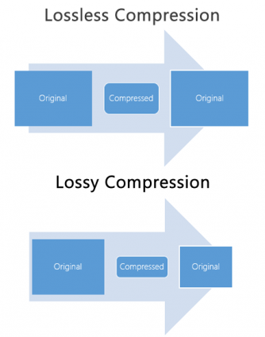

## Resources

* <https://gisgeography.com/lossless-compression-vs-lossy-compression/>

## Vocabulary

* Compression
* Lossless
* Lossy